12/08/2023

Re: Your request for provider information

**Dear Leonid Danishevsky**

Thank you for contacting us. Below is the information you recently requested regarding provider network status:

This provider is in your network:

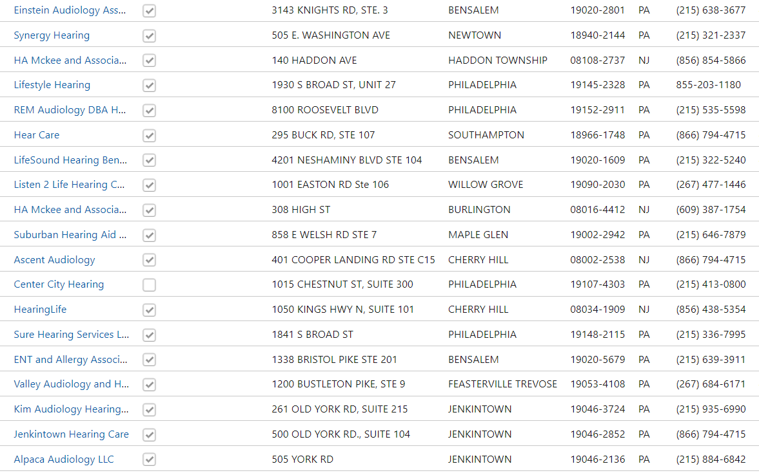

*Provider information is accurate as of the date of publication and enrollees should consult the directory or contact the plan to obtain the most current provider directory information.*

*The provider’s network status can change at any time. Please check with your provider at the time you schedule a service to confirm they are in your network. If you receive service from an out-of-network provider, your costs may be higher. Please refer to your plan documents to confirm benefit coverage.*